CHINESE VERSION OF THE FLOW CHART COMES BELOW. IT REQUIRES CHINESE FONTS THAT AREN’T ON MY COMPUTER. BUT IT WORKS ON COMPUTERS WITH THE RIGHT FONTS. IT IS A “SMARTDRAW” FILE see corrections for english chart below it.

Figure 8: Total product chain flow chart for SCIP.

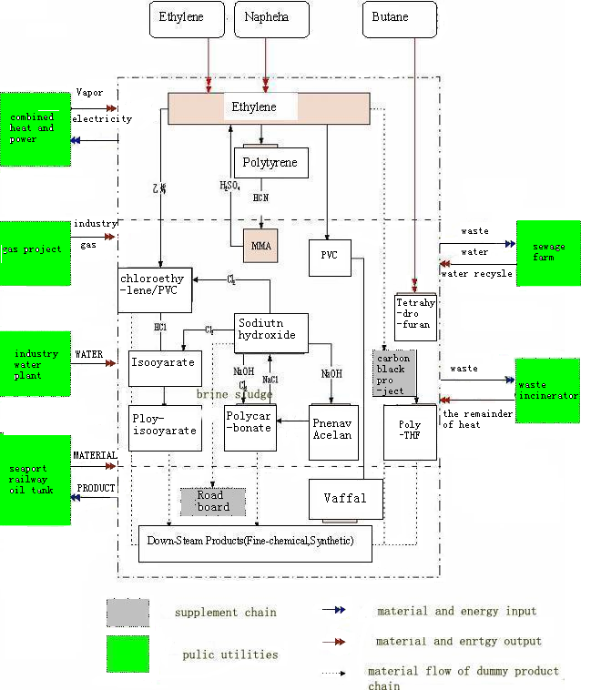
at top Naphtha is the right spelling
“vapor” should be replaced by “steam”
Polytyrene should be Polystyrene
“Sodium hydroxide” is right for box below MMA. (Caustic soda is common name.) NaOh
“ployisooyarate” should be Poly isocyanate
change road board to road bed
“Vaffal” should be vessel
“sewage farm” should be “constructed wetland”
Change “dummy project” to “proposed project”
MMA - Methyl methacrylic Acid
PVC - Polyvinyl chloride
exp
H2SO4 = sulfuric acid;
HCN = hydrogen cyanide;
PVC = polyvinyl chloride,
MMA = methyl methacrylate

PS = polystyrene

PP = polypropelene
Cinnamence? What is the Chinese word for this? It is not used in English.
Methylene diisocyanate MDI
Toluene diisocyanate TDI
Hydrogen chloride (HCl or hydrochloric acid
Natroncalk ?? What is the Chinese word for this? It is not used in English.

