A Gallery of Photos
taken by Andreas Koenig to be used in
The Eco-Industrial Park Handbook
for Asian Developing Countries

all © 2000-2001 Andreas Koenig

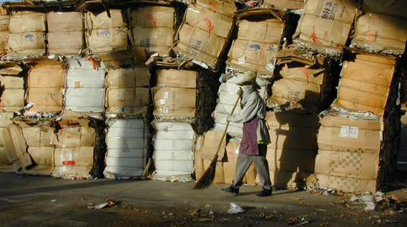
Recycling worker at Thai Press Ltd. Partners. Paper and plastics recycling company at Rayong.
© 2000-2001 Andreas Koenig

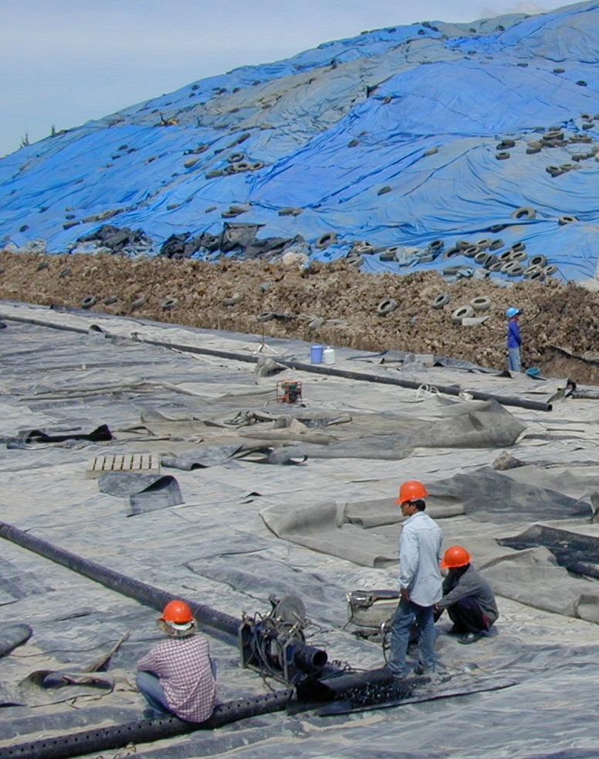

Hazardous waste landfill under construction at Map Ta Phut industrial estate near Rayong, Thailand. Two cells are full, Genco is building a third. This is the only approved hazardous waste site in Thailand.
© 2000-2001 Andreas Koenig
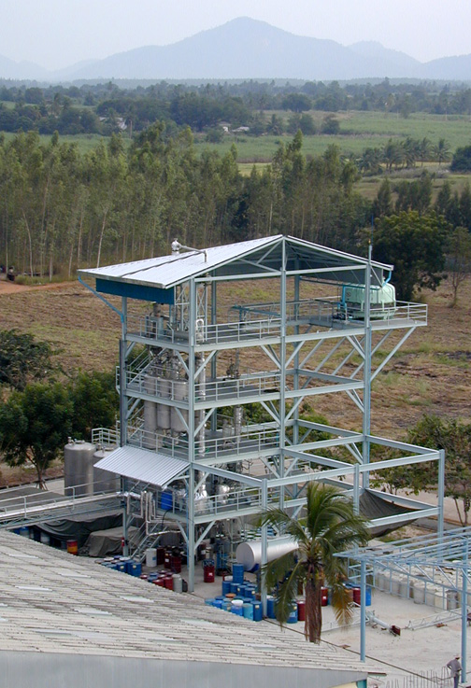

Solvent re-refinery built and operated by Recycle Engineering, a Thai-German joint venture, located in the Eastern Seaboard region south of Bangkok. © 2000-2001 Andreas Koenig

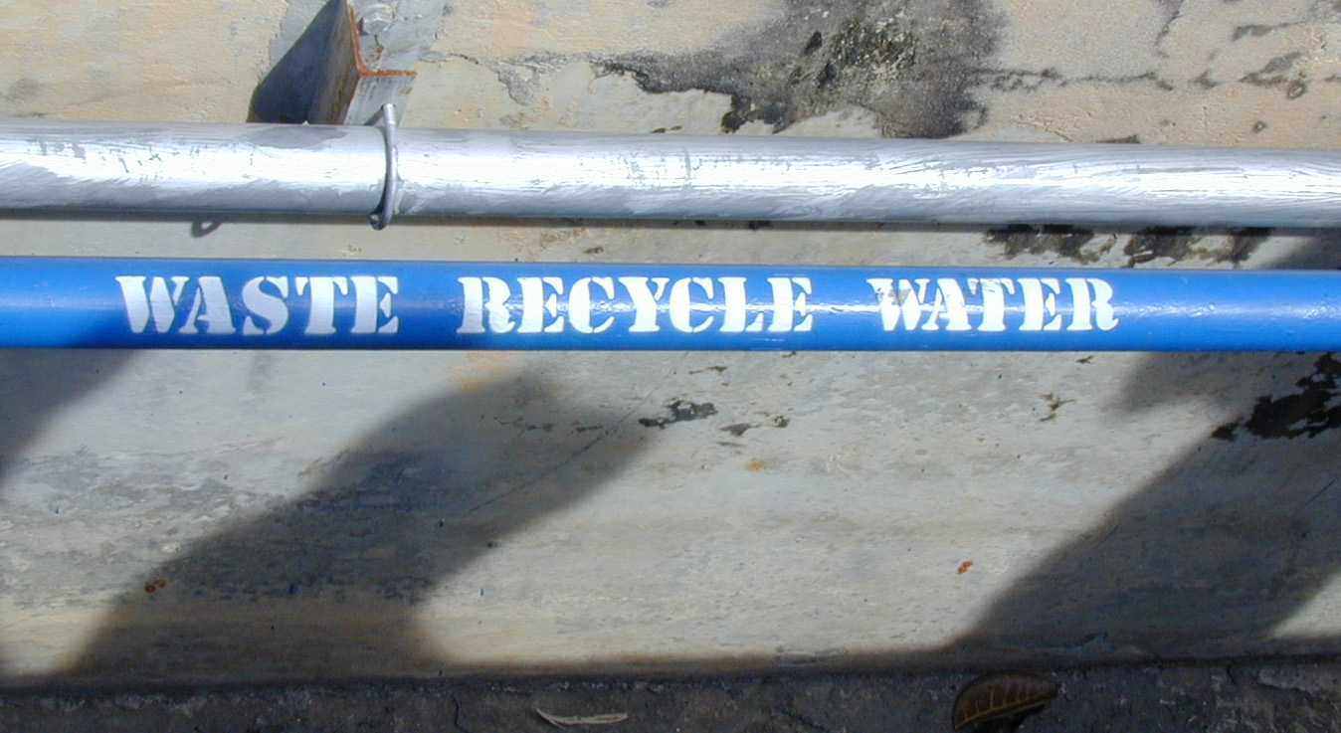

Gray-water circulation system at Ford-Mazda Factory in Eastern Seaboard Industrial Estate, Thailand. After secondary treatment the recycled water is used for irrigation of the site’s landscape.
© 2000-2001 Andreas Koenig

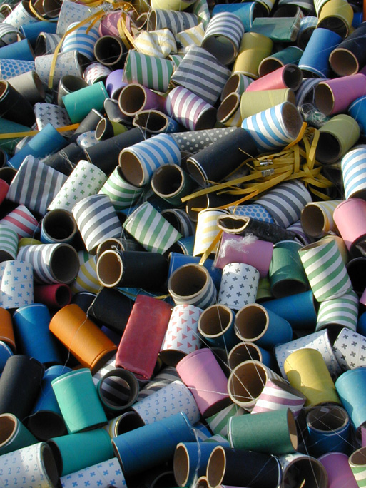
Ends of gift paper spools being recycled as industrial by-products at Thai Press, Rayong, Thailand.
© 2000-2001 Andreas Koenig

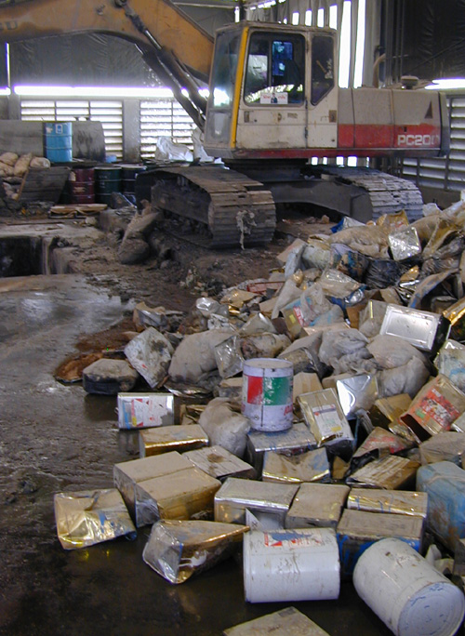
Hazardous waste at the Genco site, Thailand’s only hazardous waste disposal site. The only treatment at this facility is solidification of hazardous liquids before they go into the landfill.
© 2000-2001 Andreas Koenig
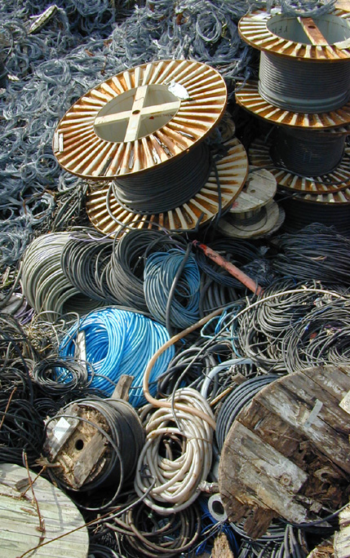
By-product cables at Rouamsate Co, a dealer in used industrial and office equipment and spare parts, Rayong, Thailand. © 2000-2001 Andreas Koenig

